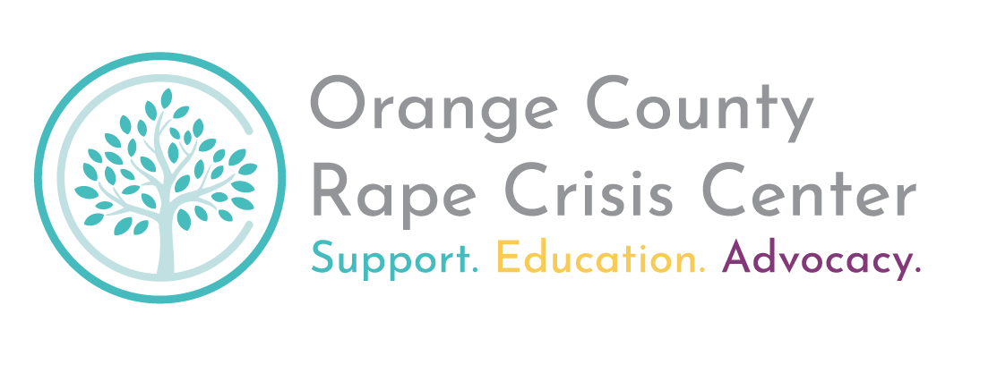

**Position Description: Client Services Director**

*The Orange County Rape Crisis Center’s mission is to stop sexual violence and its impact through support, education, and advocacy.*

*We envision a just and equitable world free of sexual violence and all other forms of oppression.*

*Our values include professionalism, excellence, service equity, social justice, community involvement, self-care, and empowerment.*

The Client Services Director position is considered full time, exempt in accordance with the Fair Labor Standards Act, and requires regular hours as well as frequent evenings and weekends. The CSD reports to the Executive Director.

Responsibilities:

1. *Program Administration*
   * Oversee direct client services rendered by the Client Services Team, including but not limited to the 24-Hour Help Line, Online Helpline (OHL), support groups, therapy, and advocacy services.
   * Work with the Client Services team to monitor progress of programmatic goals, including the regular review of data and processes, preparation of relevant grant reports and applications, evaluation of programs, and assessment of program development and resource needs.
   * Ensure program compliance with agency policies and protocols, grant conditions, and ethical standards in the field.
   * File mandated reports on child abuse/ neglect when necessary.
   * Lead the Client Services Team in the development and update of materials and systems to ensure that Center clients receive effective response, referrals, and information.
   * On an as needed basis, provide back-up assistance with staff-on-call cell phone, chat or text coverage, in house coverage, and direct client support.
   * Serve as the point person for high-needs or high-risk client cases, modeling strong advocacy and boundaries.

1. *Staff Management* : Serve as the direct supervisor for the Client Services Team, inclusive of full time client advocates as well as part-time overnight crisis response advocates.

* Work with supervisees on the follow-up and case management of clients as needed.
* Work with university or school programs to provide internship opportunities for students.
* Maintain an expertise in training staff to provide services to victims of sexual violence. Training and services must be research-based and consistent with best practices in the fields of crisis intervention and sexual violence prevention and response.

1. *Community Advocacy and Policy*
   * Develop and maintain relationships with service providers and partner agencies, including but not limited to law enforcement, medical services, domestic violence service providers, humans services, social justice, and other partners in the system of care.
   * Coordinate the Orange County Domestic Violence Sexual Assault Response Committee (DVSARC) in their efforts to monitor and evaluate community response systems.
   * Serve on relevant task forces and advocacy initiatives that work to improve the system of care for survivors.
   * Work with community partners to strengthen the system of care and create pathways for safety, dignity, and wellness for survivors.

1. *Agency Leadership*
   * Work closely with the Executive Director, bringing programmatic issues and needs to their attention regularly.
   * Work closely with the Leadership Team to ensure cross-team communication and collaboration and assist with stewarding the organization’s commitments and values in a hostile political and funding landscape.
   * Provide team leadership to the organization in the stewardship of a positive conflict culture, including continuous personal learning, modeling, and facilitation of conflict resolution.
   * Assist in the agency’s efforts to maintain self-care by organizing self-care opportunities for staff and volunteers.

1. *General Responsibilities*
   * Complete any other tasks and trainings deemed necessary by the Executive Director.
   * Work as a team member in order to achieve the mission of the Center.
   * Maintain appropriate standards of confidentiality.

Qualifications Required:

1. Minimum of 4 years experience in community-focused human services field.
2. Experience managing, leading, and supervising staff.
3. Experience working with crisis issues on an emergency, on-call basis.
4. Demonstrated effectiveness in communicating ideas both verbally and in writing.
5. Experience implementing services for immigrant, BIPOC, LGBTQIA+ and other underserved populations.
6. Demonstrated cultural awareness, humility, and competency.
7. Flexibility and ability to adapt to rapidly changing environments.
8. Commitment to self-awareness, ethical practice, and setting appropriate boundaries.

Qualifications Preferred:

1. Bilingual in English and Spanish.
2. Familiarity with community resources available for survivors of sexual violence.
3. Demonstrated effectiveness in coalition-building and/or working on multidisciplinary teams.

Candidate Profile

Successful applicants will be able to demonstrate the following management skills and attributes during the application process

* Conflict Fluency: when conflicts arise in the workplace, the CSD candidate approaches them with calm, curiosity, humility, and a commitment to forging a breakthrough.
* Systems Thinking: The candidate has a nuanced appreciation for both the limitations of our scope and the imperative to collaborate across siloes to create safety, dignity and justice for all oppressed people.
* Ethical Communication: the CSD candidate makes decisions and communicates about them in ways that center those most effected, integrates the needs of the group, and is accountable to the values of the agency.
* Strong Boundaries: The CSD candidate knows how to be approachable while maintaining strong boundaries around their professional connections.
* Reciprocity and Mutuality: The CSD candidate is able to both provide and receive constructive feedback from peers, partners, and teammates.
* Community-Oriented Approach: The CSD candidate accepts responsibility for breakdowns in communication, knows when to say “I don’t know”, and champions their team members’ contributions. In external partnerships, the CSD candidate knows how to advocate for best possible outcomes while maintaining positive relationships. This includes knowing when and how to repair harm.

* *Reports to:* Executive Director
* *Hiring Range:* $63,000- $65,000
* *Hours:* 32-40 hours per week during regular business hours a*nd* frequent nights and weekends.
* *Benefits:* Health, Vision, Dental, and Life Insurance; Generous PTO Package; 12+ Paid Holidays; Employee Wellness Stipend; Sabbatical (Longevity) Benefit for Long-Term Employees.
* *Anticipated Start Date:* August 2025

**A Note on Applications:**

OCRCC is looking for team members with creativity, enthusiasm, and a commitment to learning and growing with us. Women, BIPOC people, LGBTQIA+ people, people with disabilities, and/or survivors of trauma often underestimate themselves when job-hunting. At OCRCC we value lived experience and transferable skills over and above fancy titles or degrees.  If you have the qualities we’re looking for but may not have all of the required qualifications listed on the posting or an advanced degree, please consider applying anyway! Describe your transferrable skills in your introduction email and/or submit supplemental materials you think are relevant to the posted position.

*The Orange County Rape Crisis Center is committed to fostering the leadership of people of color, Native people, immigrants and refugees, low-income people, LGBTQ+ and trans* people, people with disabilities, survivors of sexual and/or domestic violence, and people living in the many intersections of these experiences. We strongly encourage people from these communities to apply. OCRCC does not discriminate on the basis of race, ethnicity, color, socioeconomic class, gender identity, gender expression, sexual orientation, sex, religion, disability status, citizenship status, age, veteran status, or national origin.*